YU Program/Major Assessment Template:
Mission, Goals, Objectives & Curriculum Map

College/School Name:
Department/Program Name:
Contact Name:
Email:
Phone:

I. Department/Program Mission Statement
Definition: A concise statement that outlines the guiding principles of core values of the department/program’s curriculum.
Suggested structure: “The mission of [name of department/program] is to [primary purpose] by providing [primary functions or activities] to [stakeholders]”.
Example: “The mission of the undergraduate psychology program [name of program] is to prepare students [stakeholders] for employment-in various psychology-related fields and/or to pursue advanced studies in psychology [purpose of the program] by developing their knowledge of theories and research across areas of personality, developmental, clinical, and behavioral psychology [primary activities or functions].”

Type department/program mission:

Checklist:
- Is statement clear and concise?
- Does it clearly state the purpose of the department/program, the primary functions and activities, and indicate the key stakeholders?
- Does it support and align with the mission of the school and university?
- Does it reflect the department/program’s priorities and values?

II. Department/Program Student Learning Goals
Definition: Broad conceptual statements about what you want students to learn or be able to do as a result of their program experience. Since goals are still at the conceptual level, they are not directly measurable.
Suggested structure: “Students will be able to [action verb] [object] [modifiers]”
Tip: Use verbiage from Bloom et al.’s cognitive, affective or psychomotor taxonomies if helpful to specify desired levels of performance.
- Cognitive: (know/understand, remember, apply, analyze, evaluate, create)
- Affective: (receive, respond to, value, organize, internalize)
- Psychomotor: (imitation, manipulation, precision, articulation, naturalization)
Example: Psychology majors will be able to:
- Know key concepts and central issues pertinent to the field
- Analyze psychological problems using relevant theories and research
- Evaluate scientific studies on the basis of their scientific rigor and contribution to the filed
- Create their own rigorous scientific inquiries of pertinent topics within the field and effectively communicate their findings
Type 3-5 department or program student learning goals:
1.
2.
3.
4.
5.
Checklist:
- Does each goal reflect the department /program’s mission?
- Does each goal state the overarching expectations of students in the program or having completed the program?
- Is each goal broad enough to be easily defined with several specific objectives or indicators of the goal?
- Is each goal distinctive from one another so that there is no redundancy?

III. Department/Program Student Learning Objectives:
Definition: Statements that describe the specific skills, values, knowledge, and/or attitudes that students should exhibit as a result of the program, and which are reflective of the overarching goal. Learning objectives should be stated so that they are measurable performance indicators of the larger overarching goal.
  - Objectives should:
    - Be student-centered
    - Be specific to one goal
    - Use action verbs (e.g., see verbiage associated with different categories in Bloom’s taxonomies if helpful)
    - Be measurable
  - Types of learning objectives:
    - Cognitive objectives: What students should know
    - Affective objectives: What students should care about
    - Behavioral objectives: What students should be able to do
Example of student learning objectives pertaining to a psychology program-level goal
- Goal: Psychology majors will be able to analyze psychological problems using relevant theories and research

- Objectives:
  - Students will be able to choose relevant theories and research for examining a specific psychological issue
  - Students will be able to demonstrate using theories and research to make informed recommendations pertaining to psychology-related issues and topics
  - Students will be able to employ the scientific method for analyzing a psychology-related research question

Directions: Complete the following table by listing each department/program goal in the left column. For each Program goal list 2-3 objectives in the right column. Remember that an objective is a specific, measurable, indicator of a learning goal. Tip: Use the chart (presented on next page) of action words for specific performance indicators of the various cognitive processes in Bloom’s taxonomy if helpful.
Department/Program Goal | Objectives
1. | a.
1. | b.
1. | c.
2. | a.
2. | b.
2. | c.
3. | a.
3. | b.
3. | c.
4. | a.
4. | b.
4. | c.
5. | a.
5. | b.
5. | c.

Objective Checklist:
- Is the objective clearly and simply stated?
- Is the objective written using an action verb?
- Does the objective specify observable behaviors that are measurable?
- Is it possible to collect accurate and reliable data pertaining to the objective?
- Is the objective stated so that more than one measurement method can be used to assess it?
- Is it student-centered vs. teacher-oriented? (e.g., students will be able to evaluate vs. students’ will evaluate)
Action Verbs Associated with Bloom et al.’s Taxonomy of Cognitive Processes
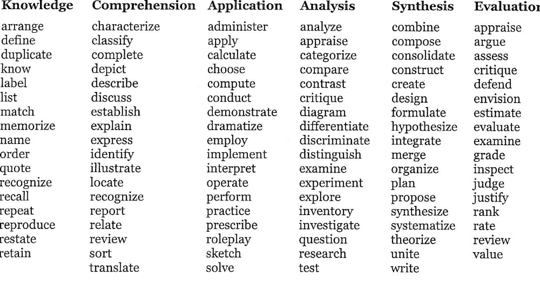

IV. Curriculum Mapping
Definition: Aligning courses with department and program level goals and objectives
Directions: Complete the table below by listing each learning objective/outcome for students in your department/program in the rows in the far left column. List the required courses/experiences in the remaining columns of the first row. Place an X in the cells of each course that targets each objective/outcome. A completed example by a psychology department is provided on the next page.
Levels Curriculum Map
Learning objectives/outcomes | Required Courses/Experiences

Curriculum Map Example
LEARNING OBJECTIVES/OUTCOMES | REQUIRED COURSES/EXPERIENCES
LEARNING OBJECTIVES/OUTCOMES | 101 | 102 | 201 | 220 | 250 | 301 | 302 | 303
Students will be able to choose relevant theories and research for examining a specific psychological issue |  |  |  |  |  | X | X | X
Students will be able to demonstrate using theories and research to make informed recommendations pertaining to psychology-related issues |  |  |  |  | X | X
Students will be able to employ the scientific method for analyzing a psychology-related research question | X | X | X

Some of the content on this form is based on material from the University of Connecticut and University of Massachusetts (Amherst) learning assessment websites.
Table adapted from the OAPA handbook program based assessment and review, University of Massachusetts (Amherst). Retrieved Nov. 8, 2013 from http://www.umass.edu/oapa/oapa/publications/online_handbooks/program_based.pdf
Table taken from Brandeis University’s Assessment website. Retrieved November 8, 2013 from http://www.brandeis.edu/assessment/learning_goals/Learning_outcomes_worksheet.pdf
Table adapted from Curriculum Mapping Template from Lehman College Office of Assessment and Planning. Retrieved Nov. 7., 2013 from http://www.lehman.edu/research/assessment/templates.php

