YU Program/Major Assessment Template:
Mission, Goals, Objectives & Curriculum Map

College/School Name: Katz School of Scienc and Health
Department/Program Name: AS in Management
Contact Name: Jessica Accurso-Salguero, PhD
Email: j.accurso-salguero@yu.edu
Phone: 646-592-4032

I. Department/Program Mission Statement
The program is wholly within the mission of Yeshiva University. While the institution already offers bachelors’ and masters’ programs in business, as well as an associate’s degree in another field, this is YU’s first associate’s degree in the Business category of the HEGIS classification. With the associate’s degree, YU expands educational opportunities to prospective students who seek YU’s unique experience but for whom a 2-year degree makes the most sense—both as a platform for pursuing work opportunities and as a potential pathway for transferring into a 4-year program. Some of the students will be well prepared for continued study in management and other business related fields at YU or other institutions of higher education. Consistent with YU’s current undergraduate population, students in the associate’s program are expected to come almost exclusively from Modern Orthodox high schools; many of these prospective students are the children and grandchildren of YU alumni. Our dual curriculum—a rich mix of Torah and Jewish Studies complemented by rigorous secular programs—is the distinguishing characteristic of YU. This curriculum and the opportunity to live in observant same-sex dorms with easy access to Kosher food and faith-based activities constitutes an important part of the YU experience that is sought after by these students and their families. This experience is not available anywhere else.

Checklist:
- Is statement clear and concise?
- Does it clearly state the purpose of the department/program, the primary functions and activities, and indicate the key stakeholders?
- Does it support and align with the mission of the school and university?
- Does it reflect the department/program’s priorities and values?

II. Department/Program Student Learning Goals
- Students will be able to understand comprehensive business management principles and theories.

- Students will be able apply business management technical skills required for entry level positions in business.

- Students will be able to apply necessary study skills and intellectual discipline for success in their field of study and after graduation.

- Students will be well prepared for continued study in management and other business related fields at YU or other institutions of higher education.
.
Checklist:
- Does each goal reflect the department /program’s mission?
- Does each goal state the overarching expectations of students in the program or having completed the program?
- Is each goal broad enough to be easily defined with several specific objectives or indicators of the goal?
- Is each goal distinctive from one another so that there is no redundancy?

III. Department/Program Student Learning Objectives:
Definition: Statements that describe the specific skills, values, knowledge, and/or attitudes that students should exhibit as a result of the program, and which are reflective of the overarching goal. Learning objectives should be stated so that they are measurable performance indicators of the larger overarching goal.
  - Objectives should:
    - Be student-centered
    - Be specific to one goal
    - Use action verbs (e.g., see verbiage associated with different categories in Bloom’s taxonomies if helpful)
    - Be measurable
  - Types of learning objectives:
    - Cognitive objectives: What students should know
    - Affective objectives: What students should care about
    - Behavioral objectives: What students should be able to do
Example of student learning objectives pertaining to a psychology program-level goal
- Goal: Psychology majors will be able to analyze psychological problems using relevant theories and research

- Objectives:
  - Students will be able to choose relevant theories and research for examining a specific psychological issue
  - Students will be able to demonstrate using theories and research to make informed recommendations pertaining to psychology-related issues and topics
  - Students will be able to employ the scientific method for analyzing a psychology-related research question

Directions: Complete the following table by listing each department/program goal in the left column. For each Program goal list 2-3 objectives in the right column. Remember that an objective is a specific, measurable, indicator of a learning goal. Tip: Use the chart (presented on next page) of action words for specific performance indicators of the various cognitive processes in Bloom’s taxonomy if helpful.
Department/Program Goal | Objectives
1. Students will be able to understand comprehensive business management principles and theories. | - Understand literary texts.
 | - Identify major concepts regarding a business enterprise and the business environment
 | - Explain major concepts regarding a business enterprise and the business environment
2. Students will be able apply business management technical skills required for entry level positions in business. | - Respond critically to other texts while integrating arguments from several sources.
 | - Provide examples of customer needs and related business opportunities
3. Students will be able to apply necessary study skills and intellectual discipline for success in their field of study and after graduation. | - Respond critically to other business and professional writing.
 | - Explain what future business leaders should know in order to be successful
 | c.
4. Students will be well prepared for continued study in management and other business related fields at YU or other institutions of higher education. | - Write a research paper.
 | - Discuss and grapple with important issues such as business ethics and environmental sustainability
 | - Develop mathematical knowledge necessary for various courses in finance, marketing, statistics, and quantitative methods.

Objective Checklist:
- Is the objective clearly and simply stated?
- Is the objective written using an action verb?
- Does the objective specify observable behaviors that are measurable?
- Is it possible to collect accurate and reliable data pertaining to the objective?
- Is the objective stated so that more than one measurement method can be used to assess it?
- Is it student-centered vs. teacher-oriented? (e.g., students will be able to evaluate vs. students’ will evaluate)
Action Verbs Associated with Bloom et al.’s Taxonomy of Cognitive Processes
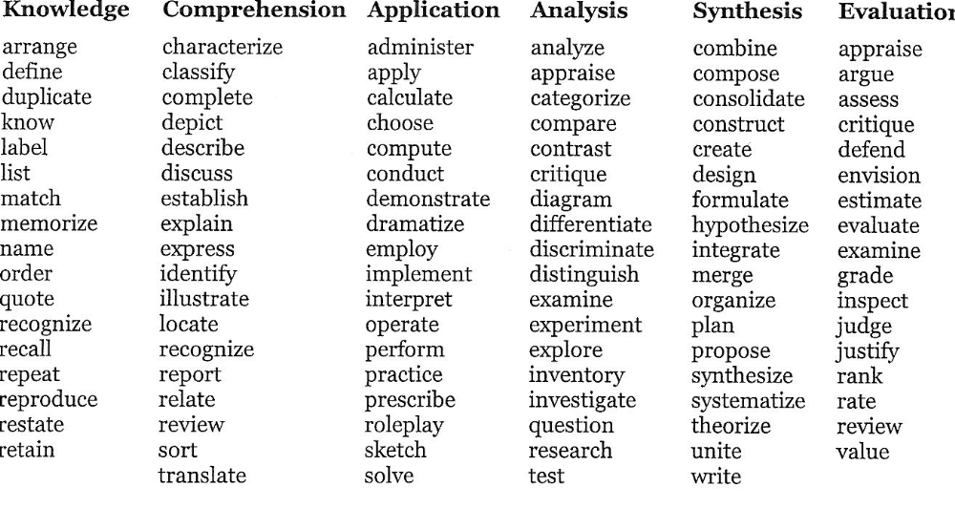

IV. Curriculum Mapping
Definition: Aligning courses with department and program level goals and objectives
Directions: Complete the table below by listing each learning objective/outcome for students in your department/program in the rows in the far left column. List the required courses/experiences in the remaining columns of the first row. Place an X in the cells of each course that targets each objective/outcome. A completed example by a psychology department is provided on the next page.
Levels Curriculum Map
Learning objectives/outcomes

 | FYWR 1020 | FYSM 1012 | SPEE 1010 | IDS 1001 | IDS 1131 | IDS 1020 | ECO 1031 | ECO 1041 | MAN 1020
Understand literary texts. | x | x | x
Identify and explain major concepts regarding a business enterprise and the business environment |  |  |  |  |  |  | x | x | x
Respond critically to other texts while integrating arguments from several sources. | x | x |  |  |  |  |  |  | x
Identify customer needs and related business opportunities |  |  |  |  |  |  | x |  | x
Explain what future business leaders should know in order to be successful |  |  |  |  |  |  |  |  | x
Write a research paper. | x | x
Discuss and grapple with important issues such as business ethics and environmental sustainability |  |  |  |  |  |  | x | x | x
Students will be prepared for the mathematical requirements of various courses in finance, marketing, statistics, and quantitative methods. |  |  |  | x | x | x

Curriculum Map Example
LEARNING OBJECTIVES/OUTCOMES | REQUIRED COURSES/EXPERIENCES
LEARNING OBJECTIVES/OUTCOMES | 101 | 102 | 201 | 220 | 250 | 301 | 302 | 303
Students will be able to choose relevant theories and research for examining a specific psychological issue |  |  |  |  |  | X | X | X
Students will be able to demonstrate using theories and research to make informed recommendations pertaining to psychology-related issues |  |  |  |  | X | X
Students will be able to employ the scientific method for analyzing a psychology-related research question | X | X | X

Some of the content on this form is based on material from the University of Connecticut and University of Massachusetts (Amherst) learning assessment websites.
Table adapted from the OAPA handbook program based assessment and review, University of Massachusetts (Amherst). Retrieved Nov. 8, 2013 from http://www.umass.edu/oapa/oapa/publications/online_handbooks/program_based.pdf
Table taken from Brandeis University’s Assessment website. Retrieved November 8, 2013 from http://www.brandeis.edu/assessment/learning_goals/Learning_outcomes_worksheet.pdf
Table adapted from Curriculum Mapping Template from Lehman College Office of Assessment and Planning. Retrieved Nov. 7., 2013 from http://www.lehman.edu/research/assessment/templates.php

