April 2025
Please share with your faculty:
Backward Design and Bloom’s Taxonomy

Backward design (see Figure 1) is a curriculum design approach that involves first identifying the program’s student learning goals and then working backwards to develop meaningful assessments to measure those goals and relevant instructional strategies to help students achieve those goals.

Figure 1: The Backward Design Model

Bloom’s taxonomy (see Figure 2) is an educational tool that can be used to help structure educational goals, assessments and instruction by categorizing cognitive processes into different levels starting from the simplest forms of processing like remembering and understanding to more complex abilities like evaluating and creating.

Figure 2: Bloom’s Taxonomy
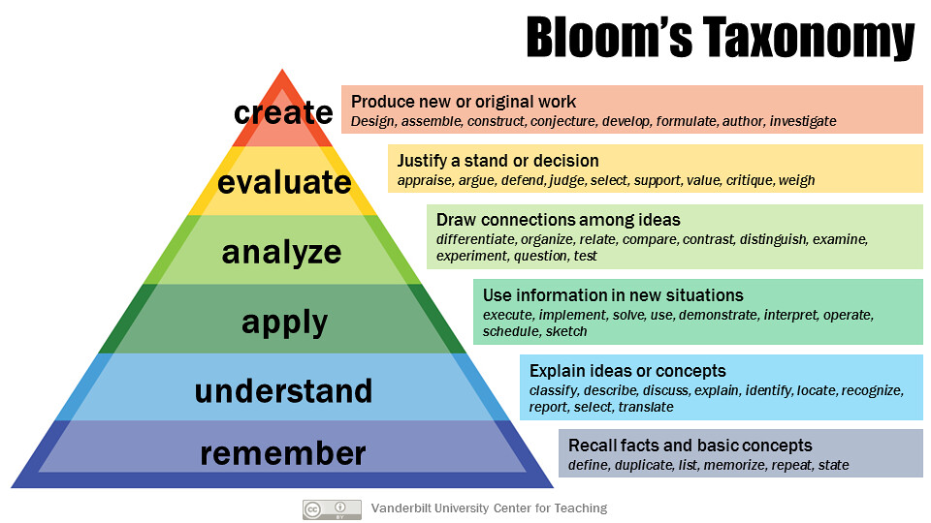

In keeping with the Backward Design Model, it is important that program goals & objectives, assessments, and instructional activities are aligned. For example, if the goal is basic recall then a multiple-choice test may be sufficient. If the goals are for students to evaluate information or to create a product, then a multiple choice test would not be an appropriate assessment. Instead, a performance-based assessment would be needed along with a rubric that evaluates how students performed on the assessment.
Examples of Backward Design:
- Science
- Outcome: Students will be able to critically evaluate scientific research
- Assessment: Students will be able to write about at least two limitations of a recent empirical article in a peer-reviewed journal
- Instructional methods: Activities will include reading, discussing, and analyzing scientific journal articles
- History
- Outcome: Students will be able to identify several causes of the Civil War
- Assessment: Students will be able to write at least 4 possible causes of the Civil War
- Instructional method: Activities will include reading primary and secondary sources, watching documentaries, and class discussions on the topic
- Religion
- Outcome: Students will be able to compare and contrast major world religions including their major beliefs, traditions, and practices
- Assessment: Students will write a comparative paper that compares and contrasts three major world religions
- Instructional methods: Activities will include reading primary and secondary sources about different religions, watching videos about different religious beliefs and traditions, and class discussions comparing and contrasting different religious ideologies.

References:

Armstrong, P. (2016). Bloom's Taxonomy. Nashville, TN: Vanderbilt University, The Center for Teaching. Retrieved April 4, 2025 from https://cdn.vanderbilt.edu/vu-sub/wp-content/uploads/sites/59/2010/06/19134035/Blooms-Taxonomy.docx

Tomaswick, L. (2018). Preparing to Teach – Backward Design. Kent State University Center for Teaching and Learning. Retrieved April, 4, 2025 from https://www-s3-live.kent.edu/s3fs-root/s3fs-public/file/Teaching%20Tools%20in%20a%20Flash%20-%20Backward%20Design%20-%20Final.pdf?VersionId=4AYmLOjtk03owMLHn6F4dQ89fnUkqyjK.

Vanderbilt’s Understanding by Design Website: Overview, Benefits of Using Backward Design, Three Stages of Backward Design & Backward Design Template
https://cft.vanderbilt.edu/guides-sub-pages/understanding-by-design/

Wiggins, Grant, and McTighe, Jay. (1998). Backward Design. In Understanding by Design (pp. 13-34). What is Backward Design? https://www.fitnyc.edu/files/pdfs/Backward_design.pdf

Check out!: DePaul Teaching Commons. Frameworks and Taxonomies of Learning. Retrieved April 4, 2025 from https://resources.depaul.edu/teaching-commons/teaching-guides/course-design/Pages/teaching-learning-frameworks.aspx

Reminder: Please remember to email me your Spring 2025 assessment reports by Friday, May 30. If you have any questions please don’t hesitate to contact me. Please also be sure to use the updated Spring 2025 report form.

